 |  |  |  |  | 2012 Maryland Open Dart Tournament  Including the 22nd Annual  Maryland State Championships  November 2,3&4th  $7,545.00 |  |  |  |  |  |  |  | 
Official Tournament Website  www.centralmddarts.leaguerepublic.com/  Contact Troy Brown  tb@usatcell.com |  |  |  |  |  |  |  |  |  |  |  |  | Featuring  “The Pink Ribbon Challenge”  (Women only) For every event each woman signs up for (whether it be singles or doubles) their name will go into a hat. At the end of tournament we will pick one name at random to win a great prize from the cmdl.
 | FRIDAY |  | SATURDAY |  |  |  |  |  |  | SUNDAY |  |  |  |  |  | MD STATES
EVENT | 7:00 PM Blind Draw Doubles 501 | T.B.D. Blind Draw Doubles Cricket | 11:00 AM Ladies Doubles 501 | 11:30 AM Men’s Doubles 501 |  | 1:30 PM Ladies Singles Cricket | 2:00 PM Men's Singles Cricket | 4:30 PM Mixed Triples 601 | 7:00 PM Chicago Style Draw | 11:00 AM Ladies Doubles Cricket |  | 11:30 AM Men’s Doubles Cricket |  | 1:30 PM Ladies Singles 501 | 2:00 PM Men’s Singles 501 | 3:30 PM LADIES STATE 501 | 4:00 PM MEN’S STATE 501
Entry Fee | $12 per Person | $12 per Person | $30 per Team | $30 per Team |  | $20 per Person→ | $20 per Person→ | $36 per Team | $12 per Person | $30 per Team |  | $30 per Team |  | $20 per Person→ | $20 per Person→ | $15 per Person | $15 per Person
1st | $240 | $240 | $200 | $300 |  | $200 | $340 | $240 | $240 | $200 |  | $300 |  | $200 | $340 | 80% PAYBACK  Valid Maryland  or DC  Drivers License  Required
2nd | $120 | $120 | $100 | $150 |  | $100 | $170 | $120 | $120 | $100 |  | $150 |  | $100 | $170
3-4 | $60 | $60 | $50 | $75 |  | $50 | $85 | $60 | $60 | $50 |  | $75 |  | $50 | $85
5-8 | $30 | $30 | $30 | $30 |  | $20 | $40 | $36 | $30 | $30 |  | $30 |  | $20 | $40
Total | $600 | $600 | $520 | $720 |  | $480 | $840 | $624 | $600 | $520 |  | $720 |  | $480 | $840
→ Singles events include a $2.00 ADO sponsoring fee.    Comfort Inn & Conference Center  4500 Crain Highway (Rte 50 & 301)  Bowie, MD 20716  301-464-0089  Special Darters Rate $84 Use Code 842813  Including full hot breakfast!! |  |  |  |  |  | Sanctioned By   |  |  |  |  | Youth Events - Ages 6-12 & 13-17  Saturday 8.00 am - Singles 401 - By age group  9.30 am - Draw Doubles - Mixed ages (501,cricket,cc)  Sunday 8.00 am - Youth /Adult - *Youth must have own partner  DISCLAIMER: The Host Association/League and/or the ADO assumes no responsibility for the adverse effects which darts may have on the amateur status of any Youth participation.
Dart Supplies By

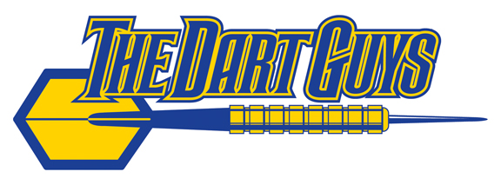

Alan Matthews
www.thedartguys.com

